Here are some fun things to do this week! Mrs. Vlies 
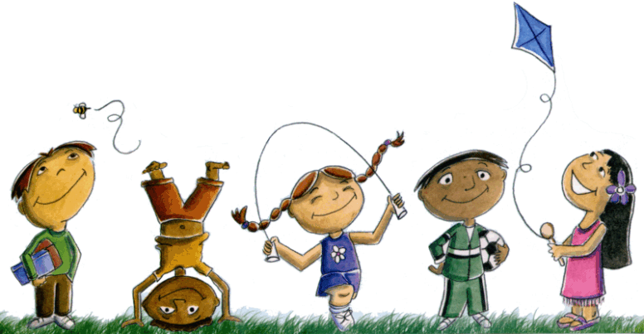
- Get the bubbles out and make bubbles.
- Make an obstacle course in your yard and ask a family member to try it out.
Try something new this week. Ideas: Learn to play a new game, try a new recipe with family, read a different book, or learn about birds or flowers….
- Write in a journal each day. Write about what happened and how you are feeling.
- Would you be invisible or read people’s minds? Create a list of the pros and cons of each. Then write a persuasive essay on why one is better than the other in your journal.
- Write a funny story about a pet who can talk and/or do extraordinary things in your journal.
- Keep reading every day. Read a little more every few days. 
- Pick five different places to read in your house and yard then read in those places.
- Arrange a curbside pickup of new books from the library. Call 920-487-2295 if you have a library card.
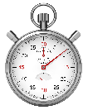
- Time yourself on how long it takes to do something.
Play “Fair or Not Fair.” Give each player a pile of coins. To play, one person suggests a trade, and the other person has to decide if that trade is fair or not fair.
Mom: Joe, I’ll trade you one nickel and FIVE pennies for just ONE of your quarters! That’s six coins for one!
Joe: Okay… wait, that’s only 5, 6, 7, 8, 9, 10 cents! A quarter is 25 cents! Not fair!

± Practice your facts by making them into a game. Match facts and answers.

