Here are some fun things to do this week! Mrs. Vlies
- Keep reading every day. Read a little more every few days. 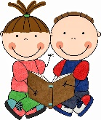
- Retell a story that you just read to someone in your family. Try to make it like a storyteller would tell it.
- Arrange a curbside pickup of new books from the library. Call 920-487-2295 if you have a library card.
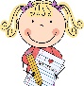
- Write in a journal each day. Write about what happened and how you are feeling.
- Would rather play inside or outside? Create a list of the pros and cons of each. Then write a persuasive essay on why one is better than the other.
- Think about a person you look up to or admire. Write a letter to them explaining why they are special to you.
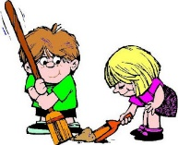
- Pick a place that interests you. Find out all that you can about that place. Make a poster or brochure that advertises this place. Convince others that they would like to travel to this place.
- Spend at least one day away from the screen this week. Make a list of things to do away from technology. Ideas: play a board game, go outside for a walk or run, jump rope, clean or organize something, start an art project....
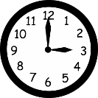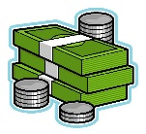
- Practice telling time on a regular clock.
Count coins, work on making change
± Practice your facts by writing them in your journal, sing them in a song, and make up stories to remember them, draw pictures to help.

