 | Sunday | Monday | Tuesday | Wednesday | Thursday | Friday | Saturday
Literacy | Design a journal to record your work and thoughts while you are at home. | Set a goal to read a certain amount each day. Record how much you read each day in your journal. | Write a card or letter to someone, address, stamp, and mail it. | Make a poem about you in your journal. Write your name and use a word to describe you with each letter. | Read aloud to someone in your family. It can be a pet or on the phone. | Create a story about your family. Write it in your journal. Ask everyone to add a part to the story. Illustrate your story. | Read your family story to your family.
Math | Make some flashcards of a math skill you would like to improve. 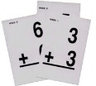 | Write a song, poem, or rap to help you remember math facts. Write it in your journal to practice. | Deal out a card from a deck to each player. The player with the highest card keeps that round. Keep playing, then tally. The one with the highest amount in the end wins. | Measure out ingredients to make a recipe or a snack. | Count the change in a money jar, piggy bank, or any coins you can find. | Make a list of 20 things to measure. Write them in your journal. Guess how long or wide they are and measure them. | Practice your math facts.
Other | Decorate your journal. Make it your own. | Start a record of the weather. Record it in your journal each day. | Make bookmarks to use and share. | Do as many jumping jacks as you can. | 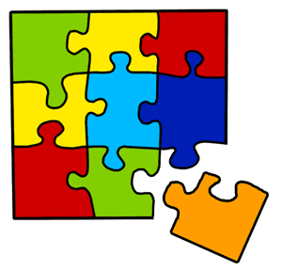  Start a jigsaw puzzle. | Clean your room or closet. | Play Simon Says or Charades with your family.

