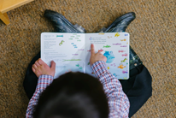  Storytimes  Join our children’s librarian, Diana for our weekly story times for you and your little ones. We hope to see you for Baby Story Time on Tuesday at 10 am or Story Hour at 10 am on Friday.  Staff Picks  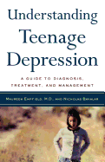  Braelyn- Understanding teenage depression : a guide to diagnosis, treatment, and management by Maureen Empfield  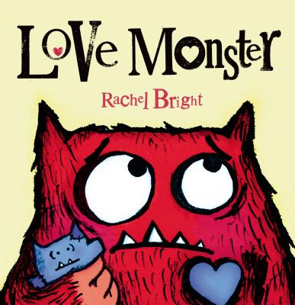  Cathy- Still Missing by Chevy Stevens  Diana- Love Monster by Rachel Bright  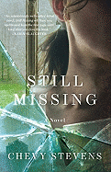  Katie- Stay Sexy and Don’t Get Murdered by Karen Kilgariff and Georgia Hardstark  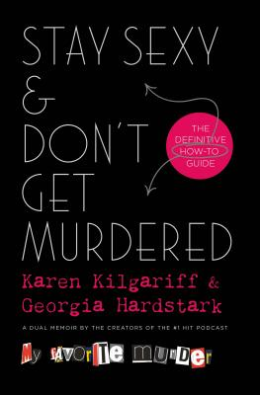  Did You Know? Library Resources  Each month we will be highlighting a different library resource. This month is on House Histories.  Complied by Wesley Cox and Harold Nell, these Histories look at houses inside the city limits of Algoma, Town of Ahnapnee and Algoma’s that no longer exist. Each entry contains information like tax rolls, obituaries, and other articles relating to the house’s owners. Stop by and see if your house inside!  Medicare 101  Tues. Feb 18th at 1 pm If you’re in the process of deciding how you will get your Medicare benefits, or you’re just doing some health insurance research for a loved one who may be eligible for Medicare, you’ve no doubt noticed that there are a lot of coverage options. Here at 5 Star Insurance Group, we like to keep things simple and easy, so we’ve compiled this educational event that breaks down the basics of Medicare.  What is Medicare?  What are the Parts of Medicare?  What are the costs? And more! | Adult Book Clubs  Mystery Book Club: We are discussing Old World Murder by Kathleen Ernst on Thurs. Feb. 6th at 5 pm.  Let’s Get Cooking!  Tues. Feb. 11th at 5 pm. We meet at St. Agnes Episcopal Church. We are looking at– Slow Cooker Revolution by Daniel J Van Ackere. Choose (1) recipe to make, sign up, make the recipes as directed, bring your cooked meal to share day of and enjoy!  Books & Brews  Thurs. Feb. 13th at 5:30 pm A laid back book club geared towards book themes, meaning participants may not have the same book. A local brew spot, Steele Street Hops, has graciously partnered with the library. So join us to discuss books, grab a brew (or some wine) and chat with us. Our current theme is Award Winners and Nominees! This is open to any book award. Need a suggestion? We can help!  Book Worms: Current read is Becoming by Michelle Obama on Tues. Feb.18th at 5 pm.  Technology Help: Internet Hour  Held every Tuesday from 11 am- 12 pm for those with simple questions about email, browsing the internet, Overdrive, Libby and more!  Library Hours  Monday – Friday: 10 am – 7 pm  Saturday: 10 am – 3 pm Sunday: Closed  Algoma public library  406 FREMONT STREET  ALGOMA, WI 54201  920-487-2295  WEBSITE: WWW.ALGOMAPUBLICLIBRARY.ORG  EMAIL: ALG@ALGOMAPUBLICLIBRARY.ORG  INSTAGRAM: ALGOMAPUBLICLIBRARY | Algoma Public Library  February 2020  Book Corner News  Romance is in the air at the Book Corner! During the month of February ALL Romance Paperback books are priced at the incredibly low price of $.10 each. In addition, all other Books, Movies, and CDs relating to Romance are Half-Off. Stop by and pick up some bargains!  The Book Corner is located at 401 Third Street and is open every Friday and Saturday from 11 am to 3 pm. All proceeds go directly to the Algoma Public Library.  Call for Volunteers  We are looking for more people to help us staff THE BOOK CORNER- 4 hours each month. Are you comfortable, with person-to-person interactions? Be an ambassador to our Library, for Algoma. We also have opportunities available behind the scenes if you prefer.  Who are the ALGOMA LIBRARY FRIENDS? We are a great group of people whose sole purpose is to help fund and promote the ALGOMA PUBLIC LIBRARY. Please contact Algoma Public Library (920-487-2295) to pick up a volunteer application or ask for more information.
February Events @ Your Library  Teen Advisory Group (T.A.G.)  Mon. Feb. 3rd at 4 pm For teens in 6th-12th grade, come discuss programming, activities at the library, and items to purchase for the Young Adult area. We’ll also have an activity to help out our community.  Maker Wednesday  Wed. Feb. 5th at 3 pm Come be creative & hands-on in our Makerspace! We’ll feature art, tinkering, and STEAM (Science, Technology, Engineering, Art, and Math) activities. Our Makerspace is open every first Wednesday of the month for a different activity! This program is aimed at patrons ages 9 and up.  Teen Creative Writing Workshop  Thurs. Feb. 6th & 20th from 3:30 to 5 pm Be a part of our Teen Creative Writing Workshop every 1st and 3rd Thurs. We will have writing prompts and activities for those needing inspiration. Sharing of new or old pieces is encouraged, but not required.  Algoma Library Friends Meeting  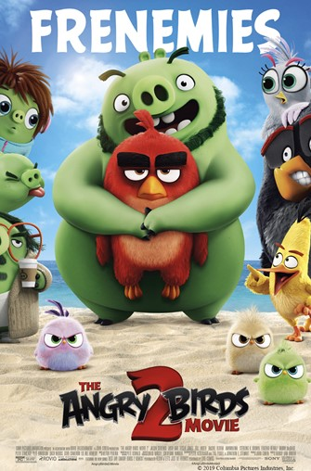  Mon. Feb. 10th at 10:30 am Show your love for the library by joining the Friends at the monthly meeting. The Friends work hard to support everything the library does. The meetings are always open to everyone.  After School Movie  Fri. Feb. 7th at 3:15 pm showing The Angry Birds Movie 2. Rated PG. Popcorn provided.  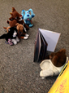  Stuffed Animal Sleepover  Fri. Feb.7th at 5:30 pm The Library will be having our Annual Stuffed Animal Sleepover. Bring in a stuffed animal and wear your PJs to this special evening storytime. We will be reading stories, making a craft, and tucking the animals in for a sleepover at the library! Pick up your animals anytime starting Saturday morning to find out what your animals were up to! | Teen-After School Games  Mon. Feb. 10th at 3:30 pm After a long day of learning come to the library to unwind with friends. We will have board games, card games, and, once in a while, video games. All games will be provided by the Library. Snacks will, on occasion, be provided.  Adult Creative Writing  Tues. Feb. 11th at 1 pm. Connect with other Adults for some fun creative writing every 2nd Tues of the month. We have writing prompts and activities for those needing inspiration. Sharing of your piece is not required.  Memory Café  Wed. Feb. 12th from 10-11:30 am This month we are making valentines! This café is geared for individuals and their caregivers who are dealing with the various stages of Alzheimer’s and dementia. Each café will entail either a speaker or an activity and a snack. To ensure we have enough supplies on hand we are asking people to call ahead to let us know. We hope you can come join us! No sign up necessary.  Afternoon Matinee  Wed. Feb. 12th at 1 pm Mary Poppins Returns. Mary Poppins returns during Michael's most desperate hour to lend him a helping hand. With his house in danger of being repossessed, she whips up a little magic to remind him of the importance of family. Bring your lunch along! Rated PG.  Lego© Club  Thurs. Feb. 13th at 3 pm. This week in LEGO © Club we will have free play. So come build something extraordinary! For grades K-5.  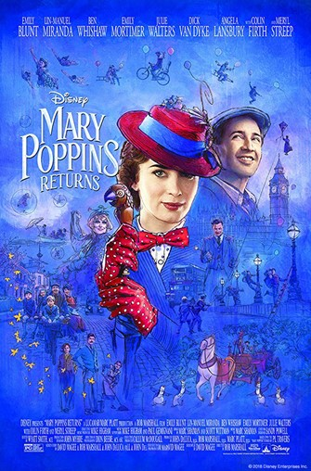 | Zentangle Hearts  Fri. Feb. 14th at 3 pm Do you want to do something special for someone you love, but are running out of time? Come stop by the Library for a Tutorial on how to make Zentangle Hearts just in time for Valentine’s Day! SIGN UP REQUIRED. Must be in at least 6th grade to take part. Please call (920) 487-2295, Facebook message us or email (alg@algomapubliclibrary.org), to sign up today. Spots are limited.  Library Board Meeting  Mon. Feb. 17th at 4 pm The Library Board is the governing body of the library. They meet each month to pay bills, discuss policy, and make sure the library is doing well. Public is always welcome. You can find the agendas and minutes at http://www.algomapubliclibrary.org/library-board.html  After School Movie  Fri. Feb. 21st at 3:15 pm showing  Dora and the Lost City of Gold Rated: PG. Snacks Provided.  Lego© Club  Thurs. Feb. 27th at 3 pm  Program for grades K-5. Join us for the LEGO Club! We'll be doing a Lego Card Challenge.  Frozen Interactive Movie  Fri. Feb. 28th at 3:15 pm Join us for a fun showing of Frozen (2013)! A young woman must break a curse that has plunged her kingdom into eternal winter. In order to do so, she must find her estranged sister with the help of a mountaineer and a reindeer. Come have fun with Elsa and Anna at the library. This is no ordinary showing either! Singing along is encouraged. Rated PG. There will be snacks included.

