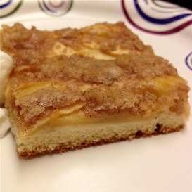
Apple Kuchen
Ingredients
½ cup milk
¼ cup shortening
1 egg
1 teaspoon vanilla extract
1 ½ cups all-purpose flour
½ cup white sugar
1 tablespoon baking powder
½ teaspoon salt
5 apples - peeled, cored, and sliced, or more to taste
Topping:
1 cup white sugar
¼ cup butter, melted
¼ cup all-purpose flour
4 teaspoons ground cinnamon

Directions
Step 1 Preheat oven to 350 degrees F (175 degrees C).
Step 2 Beat milk, shortening, egg, and vanilla extract together in a bowl until smooth. Stir 1 1/2 cups flour, 1/2 cup sugar, baking powder, and salt into milk mixture until dough comes together. Spread dough out into the bottom of a rimmed baking sheet.
Step 3 Spread apples over the dough on the baking sheet.
Step 4 Stir 1 cup sugar, melted butter, 1/4 cup flour, and cinnamon together in a bowl until topping is combined. Sprinkle topping over apples.
Step 5 Bake in the preheated oven until apples are tender and topping is golden, about 40 minutes.
Total: 55 mins

