**“Know Algoma”**

**Scavenger Hunt**

1. What year was the Bank of Algoma Building (now Weber Insurance) built?
2. What color is the glass pumpkin in BellaLuna Apothecary’s window?
3. How many footsteps are outside the Pizza Bowl? ____________
4. What are the names of the two stores on either side of the newest mural in Algoma?
   1. ____________________________________
   2. ____________________________________
5. What company made the gas pumps at Deep Rock?
6. List two book titles in the window at the Yardstick?
   1. _______________________________
   2. _______________________________
7. What is coming soon to the Skaliwag Burger building?
8. What post number is the Ernest Haucke American Legion Post?
9. How many bikes can you count in the yard at the Dodge Antique shop?
10. What color eyes does the Skaliwag’s chef pirate have?
11. What animal is on the mural at the Robert Ray Gallery?
12. When is the next Raku fire at Clay on Steele?

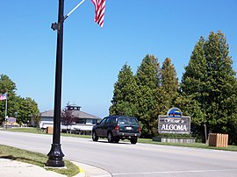

1. What does Algoma mean?
2. When was the Von Stiehl Winery established?

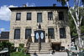

1. What are Steele Street Floral’s hours?
2. What item is in the window at Six Ten Fourth Street?
3. How many pumpkins do you see in Second Hand Rose’s window?
4. What is the Wednesday special at Hotel Stebbins?
5. Name something on the drop box at the library?
6. List three items you found in Amber’s Attic storefront window?
   1. _____________________________
   2. ___________________________
   3. __________________________
7. Officer Ron Leist is honored in Algoma. What year was he born?
8. What is the daily launching fee for a resident at the harbor?
9. Algoma’s first lighthouse was built in what year?

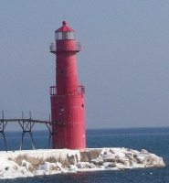

1. Algoma is the capital of what?
2. What day of the week is the library open until 7:00 PM?

**Bonus Question:** How many wall murals did you find in Algoma?

**Please bring in your completed paper for a prize at the library.**