Here are some fun things to do this week! Mrs. Vlies 

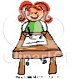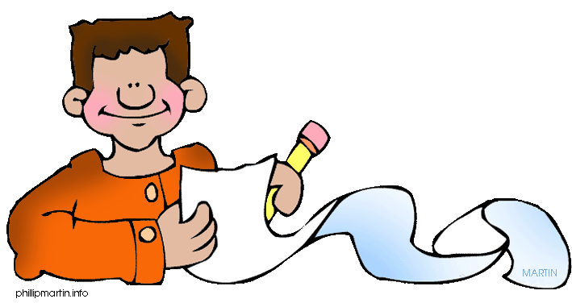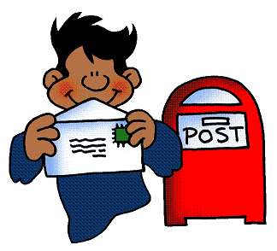
- Write in a journal each day. Write about what happened and how you are feeling.
- You are building a new city! What types of things do you think your city needs? How will you convince people to move to your new city? Write in your journal.
- Make a card for someone you love and mail or give it to them. Write a message to tell them what they mean to you.
- Keep reading every day. Read a little more every few days.
- Read to someone over the phone. 
- Challenge yourself to read something that you may not ordinarily read.
- Arrange a curbside pickup of new books from the library. Call 920-487-2295 if you have a library card.

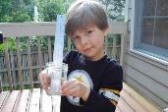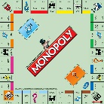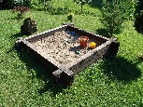
- Measure how tall or long things are in your yard and house. Write down the measurements in your journal.
Play a board game that involves money (like Monopoly) with your family.
± Practice your facts in the sand or with chalk or in your journal. Be creative.
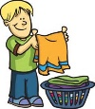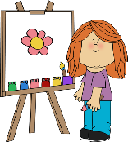
- Make up a competition with someone at home (or who you talk to). See who can do the most chores, do the most pushups, make the tallest tower, etc. during the day or week.
- Draw a picture of a happy moment from the past few weeks and put it in your journal.
- Challenge yourself to do more. Ideas: help your parents, learn more about something you are interested in, exercise more, etc.

