 | Sunday | Monday | Tuesday | Wednesday | Thursday | Friday | Saturday
Literacy | Read what you have written so far in your journal. Keep writing your thoughts down each day. | Look at your goal to read a certain amount each day. Keep recording how much you read each day in your journal. | Listen to someone read a story to you. It could be an online story or maybe someone on the phone. | Write a story about 3 places that you would like to visit someday in your journal. What do these places have in common? | With a partner, take turns reading a story to each other. While listening, draw what you saw in your mind. Compare pictures. | Write a review of your favorite movie and try to convince others to watch the movie in your journal. Then make a poster to promote it. | Pop some popcorn and snuggle up with a good book.
Math | Guess and check. Guess how many heads and tails you will get when flipping a coin. Then flip a coin 100 times. Record how many heads and tails. | Have a paper airplane contest. Make a few different plane and fly them. Measure to see which flew the farthest. | Practice math with sidewalk chalk.  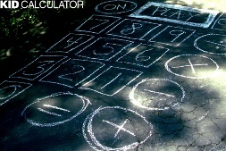 | Skip count by 10s, 5s, 2s, 3s, 12s, etc. Count as high as you can.  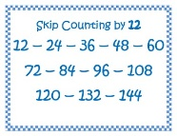 | Take a deck of cards. Turn over two cards at a time. Practice adding, subtracting, multiplying or dividing. 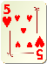 | Practice telling time on a regular clock. | Count how many electrical outlets are in your house, how many lightbulbs, how many drawers, etc. Write your counts in your journal.
Other | Show the people around you that you appreciate them. Compliment them or do something for them. | Make a plan in your journal of a garden you can plant later this spring. | Make up a new game. Write out the directions and rules. Try it out with your family.  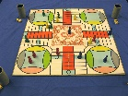 | Help someone in your house with a chore. | 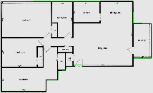  Make a map of your house in your journal. Make a fire escape plan. | Have a dance party. Turn up the music and dance. | 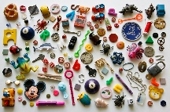  Play I Spy with your family. Try using the clue “It starts with the letter……”

