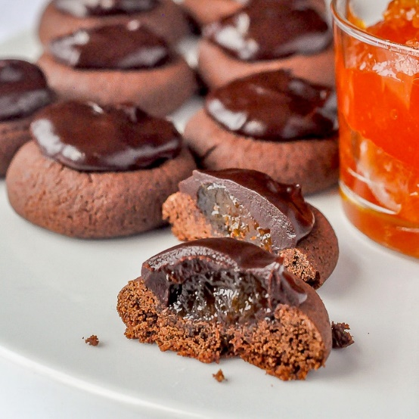
Sachertorte Cookies
1 cup butter
4 1/2 oz. Instant Chocolate pudding
1 egg
2 Cups flour
Cream butter and pudding, add egg, and flour
Shape into 1 inch balls and roll in sugar
Place on parchment covered cookie sheet and make a thumb print.
Bake @ 325 for 12 to 15 minutes.
Let cool Fill with jam ( I prefer raspberry ) Topping 1/2 cup choc chips melted with 3 tbls of butter Cover the jam with melted chocolate
Let set and enjoy

